**Wetland Prac:** Bird Monitoring

It is important to know how the bird population of our wetland is changing over time. Many different species arrive at the Wetland depending on the availability of different foods. For example, the fish and macroinvertebrates in the water are easy pickings for carnivorous birds, while many different plant species provide insects, nectar and shelter for a diverse range of bird species. You will use binoculars and bird identification charts to identify and count the variety of birds using the wetlands. You will also need to consider the following things when observing your birds

* **Description** – observe the shape of different structures, including the body, head, wings, legs, feet & beak, as well as the colours and patterns of these structures.
* **Behaviour** – observe what the birds are doing and how they are interacting with each other. Look at the different ways in which they move and how they communicate.
* **Suspected diet** – observe any birds that are feeding otherwise look at the shape of the beak
* **Impact on the wetland** – consider how the birds might impact on water quality and other organisms that live at the wetland

C:\Users\georal\AppData\Local\Microsoft\Windows\Temporary Internet Files\Content.IE5\O9VY6EEN\MC900060340[1].wmf***Handy Hints***

Sit in each location

and quietly monitor

the birds for 15 minutes.

Remember to record

on your data sheets

Choose 3 locations, and mark them on your map below





You can also make **opportunistic sightings**, as you are walking from place to place, just be sure to note that.

Make notes of the **number of**

**each species** you saw, the **type of**

**habitat** they were in and whether they were **flyovers**.

C:\Users\georal\AppData\Local\Microsoft\Windows\Temporary Internet Files\Content.IE5\9U63DFDD\MC900123883[1].wmf

C:\Users\georal\AppData\Local\Microsoft\Windows\Temporary Internet Files\Content.IE5\V5RNURZB\MM900236249[1].gif

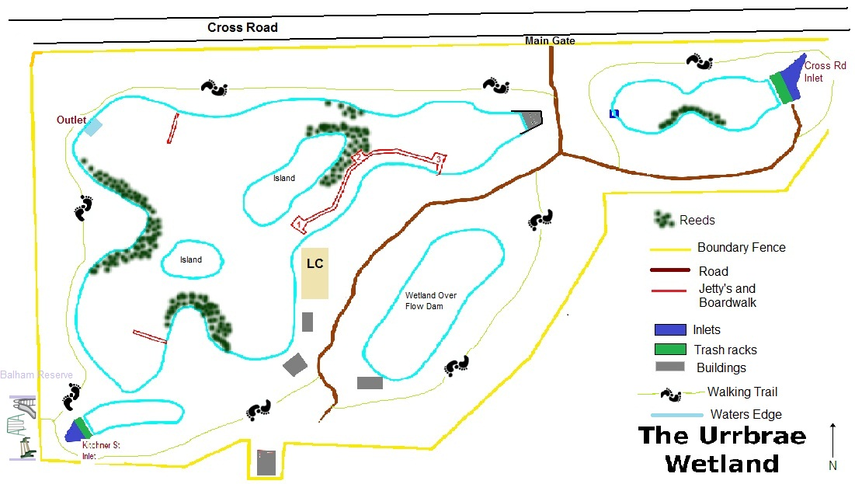

**Discussion Questions**

**Question 1**: Bird monitoring surveys are completed at the Urrbrae Wetland twice per week. Why is it important to monitor the bird populations at the Urrbrae Wetland?

|  |
| --- |
| Provides information relating to richness and abundance of bird species which is a good indicator of ecosystem health. Having data on bird populations also allows us to detect changes in populations (over population, declining populations) and question possible causes. It also allows us to assess population responses to management activities (dredging, sed. ponds, infrastructure construction, etc). |

**Question 2:** What 3 species of birds were the most common at the Urrbrae Wetland?

Why do you think this is?

|  |
| --- |
| **Wood Ducks** and **Black ducks** are the most common. This is because the biotic and abiotic factors favour these species. For example Wood duck are graziers and so like to graze the paddock up at Urrbrae Farm and then come down to the wetland for resting, nesting (etc) as there are trees and shrubs that provide protection from predators. Black ducks are common as they feed on Macroinvertebrates present in the water, there duck are also quite territorial and dominate over other birds.  The 3rd sp. will vary and may include a ‘bush bird’ such at rainbow lorikeet, particularly if the gums are flowering. The wetland as a high diversity of birds but not a high abundance of each, probably due to the lack of resources (e.g. food, aquatic plants, etc) |

**Question 3:** The Urrbrae Wetland does not have a large population of small birds (robins, wrens, etc). Why do you think this is?

|  |
| --- |
| There is not a lot of understory present. Small birds like bushy areas and plants that have small seeds and berries (there are not that many present at the wetland). Also many of these little birds can only fly very short distances and need ‘corridors’ of vegetation. There are NO vegetative corridors leading to the Urrbrae Wetland and therefore no safe way for the small birds to migrate here. |

**Questions 4:** What are the problems associated with having highly territorial birds (noisy minors) in a small area, such as the Urrbrae Wetland?

|  |
| --- |
| Highly territory birds are often very aggressive and will scare, attack and chase other birds out of their ‘space’ , therefore decreasing the diversity of birds in an area. |
| /2 |

**Questions 5:** Give 4 biotic and 4 abiotic factors that affect the bird populations at the Urrbrae Wetland. Choose one from each and explain how and why it could affect the bird populations.

|  |  |
| --- | --- |
| Biotic | Abiotic |
| Plants – need suitable populations to provide shelter, food, and nesting. | **Water –** especially for the water birds |
| Territorial birds – noisy minors | **Chemical Pollution –** affect the heath of the birds. Sick birds don’t breed and are under able to predators. |
| Predators – Foxes, cats, hawks, kookaburras | **Climate –** Adelaide’s has a temperate climate (cold wet winters, hot, dry summers) |
| A Mate – to maintain and increase abundance, a mate is required | **Design of the wetland –** not large, long tacks of water therefore no large water birds (pelicans / swans) **Islands provide protection** |
| Invertebrates – aquatic and terrestrial populations are vital as they are the base of the food chain.  /5 | **/5** |

**EXTENSION:** From your bird monitoring at the Urrbrae Wetland, choose 1 observation and develop a question that you could investigate further.