**Wetland Prac:** Bird Monitoring

It is important to know how the bird population of our wetland is changing over time. Many different species arrive at the Wetland depending on the availability of different foods. For example, the fish and macro invertebrates in the water are easy pickings for carnivorous birds, while many different plant species provide insects, nectar, and shelter for a diverse range of bird species. You will use binoculars and bird identification charts to identify and count the variety of birds using the wetlands. You will also need to consider the following things when observing your birds

* **Description** – observe the shape of different structures, including the body, head, wings, legs, feet & beak, as well as the colours and patterns of these structures.
* **Behaviour** – observe what the birds are doing and how they are interacting with each other. Look at the different ways in which they move and how they communicate.
* **Suspected diet** – observe any birds that are feeding otherwise look at the shape of the beak
* **Impact on the wetland** – consider how the birds might impact on water quality and other organisms that live at the wetland

C:\Users\georal\AppData\Local\Microsoft\Windows\Temporary Internet Files\Content.IE5\O9VY6EEN\MC900060340[1].wmf***Handy Hints***

Sit in each location

and quietly monitor

the birds for 10 minutes.

Remember to record

on your data sheets

Choose 2 locations, and mark them on your map below





You can also make **opportunistic sightings**, as you are walking from place to place, just be sure to note that.

Make notes of the **number of**

**each species** you saw, the **type of**

**habitat** they were in and whether they were **flyovers**.

C:\Users\georal\AppData\Local\Microsoft\Windows\Temporary Internet Files\Content.IE5\9U63DFDD\MC900123883[1].wmf

C:\Users\georal\AppData\Local\Microsoft\Windows\Temporary Internet Files\Content.IE5\V5RNURZB\MM900236249[1].gif

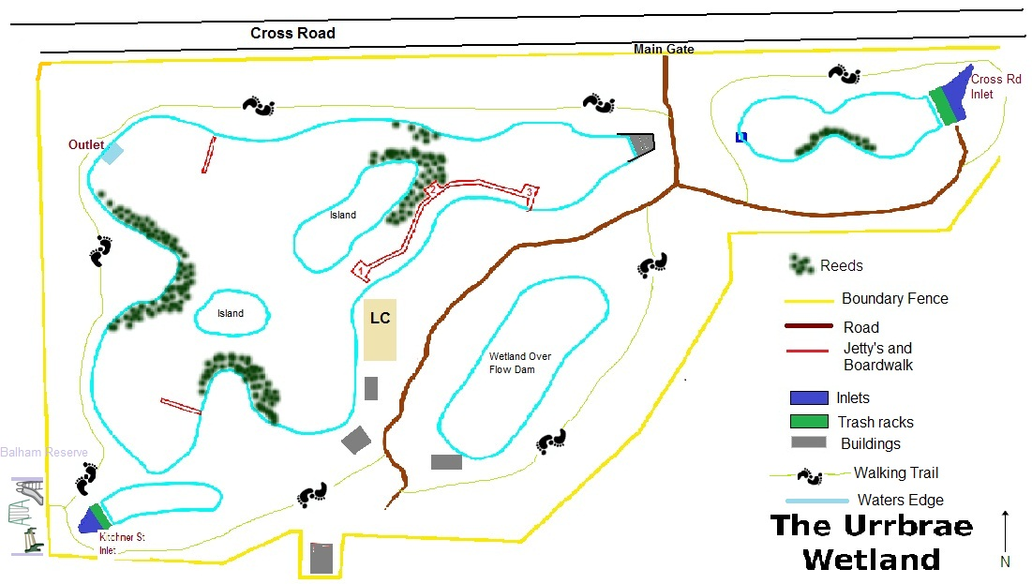

**Discussion Questions**

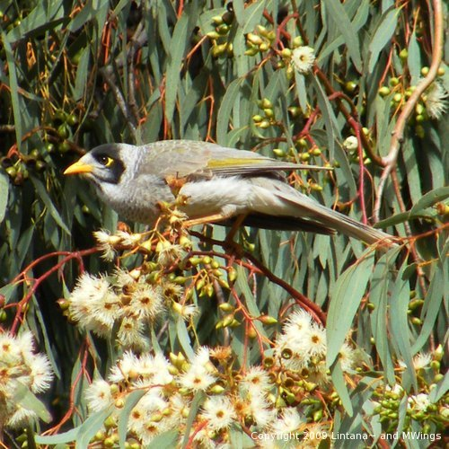

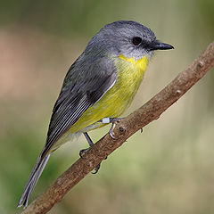

C:\Users\georal\AppData\Local\Microsoft\Windows\Temporary Internet Files\Content.IE5\V5RNURZB\MC900383474[1].wmf

**Question 1**: Bird monitoring surveys are completed at the Urrbrae Wetland twice per week. Why is it important to monitor the bird populations at the Urrbrae Wetland?

|  |
| --- |
|  |
|  |
| /2 |

**Question 2:** What 3 species of birds were the most common at the Urrbrae Wetland?

Why do you think this is?

|  |
| --- |
|  |
|  |
|  |
| /4 |

**Question 3:** The Urrbrae Wetland does not have a large population of small birds (robins, wrens, etc). Why do you think this is?

|  |
| --- |
|  |
|  |
| /2 |

**Questions 4:** What are the problems associated with having highly territorial birds (noisy minors) in a small area, such as the Urrbrae Wetland?

|  |
| --- |
|  |
|  |
|  |
| /2 |

**Questions 5:** Give 4 biotic and 4 abiotic factors that affect the bird populations at the Urrbrae Wetland. Choose one from each and explain how and why it could affect the bird populations.

|  |  |
| --- | --- |
| Biotic | Abiotic |
| 1 | **1** |
| 2 | **2** |
| 3 | **3** |
| 4 | **4** |
| Explain:  /5 | **Explain?**  **/5** |

**EXTENSION:** From your bird monitoring at the Urrbrae Wetland, choose 1 observation and develop a question that you could investigate further.

|  |
| --- |
|  |

